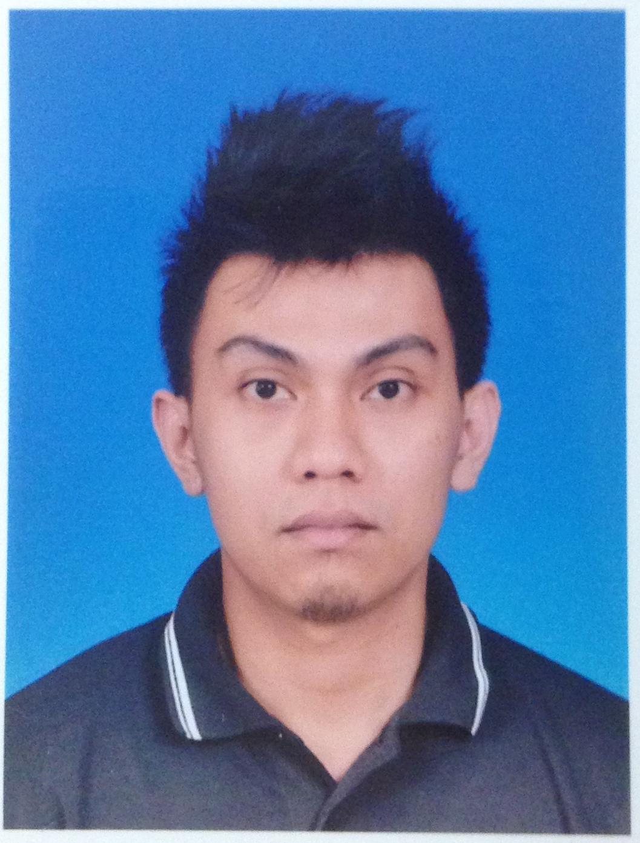

AHMAD HAMIZI BIN HARIS

Contact Info

Permanent Address : 11, Jalan Cekak Musang 10/2, Seksyen 10, 40100 Shah Alam, Selangor
Telephone No. : 603-55231264
Mobile No. : 012-2832741
Email : a.hamizi87@gmail.com

Personal Particulars

Age : 28 years
Date of Birth : 26th December 1987
Nationality : Malaysia
Gender : Male
Marital Status : Single
IC No. : 871226435183
Permanent Residence : Malaysia

Objectives

To improve my knowledge, skill and gain experience to go further in engineering field, safety and health
Educational Background

Level
Field of study : Certificate of Safety & Health Officer (SHO)
Institute/University : Skill Solution Sdn Bhd.
Graduation Date : March 2014

Degree
Field of study : B.A Hons In Electronic Engineering (Communication)
Institute/University : University Teknologi Mara (UiTM) Shah Alam
CGPA : 2.59
Graduation Date : February 2012
Diploma
Field of Study : Diploma In Electrical (Electronic)
Institute/University : Universiti Teknologi Mara (UiTM) Pulau Pinang
CGPA : 2.53
Graduation Date : December 2008

Primary/Secondary School/SPM/"O" Level
Field of Study : Electrical and Electronic Engineering
Institute/University : Sekolah Menengah Teknik Klang, Selangor
Grade : 2A 2B 6C 1D
Graduation Date : December 2004

Training

- Attend AutoCad training at SIRIM bhd. (basic & advanced)2005
- Attend safety training at Lafarge Cement.(2013)
Top Skills

(Proficiency: Advanced – Highly experienced; Intermediate – Familiar with all the basic functionalities; Beginner – Just started using or learning the skill)
Skill | Proficiency
Microsoft Office | Advanced
Autocad Software | Intermediate
C++ Programming | Beginner

Additional
- Able to work independently or in group
- Interested to work in challenging environment
- An analytical minded person
- Able to work under pressure
- Able to learn fast
- Able to give full commitment to the job
- Able to work for long hours

Experience

Company’s Name : Maxis Broadband Sdn. Bhd
Duration : 2nd May 2012 until present
Position : Engineer
Responsibilities :

(Product Service Engineering Department)

AES (Automated Enforcement System)
Corporate roll-out - Istana Arau
- Penang Development Corporation
- Citibank Penang
- Lafarge Cement
- Site survey and technical proposal on telecommunication project
- Site supervision and coordination
- Involve in managing contractor for installation, testing and commissioning
- Help to troubleshoot project issues

(Implementation & Engineering Department)

- Coordinating between vendor and engineering department for quotation purpose.
- Prepare and obtain approval for documents request.
- Represent department to communicate with procurement department to seek OA creation.
- Managing the DRO process for the project.
- Monitor GR process until the project is close which include provide the DRO list, do audit on the amount, prepare the documentation checklist and closure letter to vendor.

(Engineering Network Services Department)

- Handle migration project (MSAN – IMS)
  - Trigger switching and provisioning team to provide latest port assignment.
  - Liaise with Huawei on the new port assignment.
  - Responsible on migration activities.
  - Help to troubleshoot migration issues.
  - Liaise with ALU with MSAN H248 migration.

- Migration E1 ( MSAN/ANYMEDIA – IPDSLAM) (380 Circuit)
- Manage, planning and oversee the end to end migration process.
  - Physically validate the circuit ID at site for migration.
  - Test the new E1 link to make sure there is no error.
  - Pull the cable and verify with NMC the correct alarm.
  - Re-test the link using athran.
  - Need to attend at customer end site upon complaint and access granted to configure the athran.

- Fiber infrastructure
- Manage and oversee the end to end structure for fiber.
- Interface between vendor and project management.
- Management reporting service reporting and sponsoring service delivery meetings.
- Responsible on all engineering, planning, commissioning, material and all other technical services.
- Responsible for clarifying the project design and handling designs changes during the project implementation.

Company’s Name : Sirim Qas International Sdn Bhd
Duration : 15 November 2010 until 15 January 2011 (Internship)
Responsibilities : Product testing (Communication and Multimedia)

Company’s Name : Chungco Technology Sdn Bhd.
Duration : June 2011 until August 2011
Position : Junior On-Site Technician (Part time)
Responsibilities : Pc and printer Hardware Service named Mastercare.
- System and network maintenance
- Replacement of contract equipment beyond repair

- Diploma
Final year project : Anti bag snatching alarm

- Degree
Mini project : Intelligent fan (Assembly)
Final year project : Design and simulation of low noise amplifier
Languages

(Proficiency: 0=Poor – 10=Excellent)
Language | Spoken | Written
Bahasa Malaysia | 10 | 10
English | 8 | 8
Preference

Own Transport : Yes (car, motorcycle)
Willing to Travel : Yes
Expected Salary : RM3800

References

Azalan Yacob
Specialist
Maxis Broadband Sdn Bhd
Level 14, Menara Maxis
Kuala Lumpur City Centre
Off Jalan Ampang.
50088 Kuala Lumpur.
Contact No. : 012-2049124

Abdul Fatah Muhammad
Manager
Maxis Broadband Sdn Bhd
Level 14, Menara Maxis
Kuala Lumpur City Centre
Off Jalan Ampang.
50088 Kuala Lumpur.
Contact No. : 012-2770134

